CHAPTER 1 : INTRODUCTION

Introduction
Air-Writing is a contactless method of human–computer interaction in which users write characters in the air using hand movements instead of physical input devices. With advances in computer vision and artificial intelligence, hand gestures can now be captured and interpreted in real time using a webcam.This project focuses on developing an Air-Writing and Character Recognition system that tracks hand movements and converts air-written characters into digital text, providing a natural and touch-free input solution.

  - Problem Statement
Conventional input methods require physical contact and are not always suitable in all environments. There is a lack of efficient systems that can accurately recognize characters written in the air using hand gestures. Variations in writing style and environmental conditions further increase recognition difficulty.This project aims to address these challenges by developing a real-time air-writing recognition system using machine learning techniques.

  - Project Objectives & Goals
The main objectives of this project are:
- To capture hand movements using a webcam
- To detect and track air-written gestures
- To recognize alphabets and digits accurately
- To display recognized characters as text output
- To ensure real-time performance with a simple and user-friendly interface

  - Scope & Limitations
Scope of the Project
- Supports real-time recognition of characters written in the air using hand gestures.
- Converts recognized air-written characters into digital text output.
- Provides a contactless and natural input method for human–computer interaction.
- Can be extended for applications in education, accessibility, and smart interfaces.
Limitations of the Project
- Currently supports a limited set of alphabets and digits for recognition.
- Recognition accuracy may vary under poor lighting conditions or complex backgrounds.
- Performance depends on proper hand positioning and smooth air-writing gestures.
- Requires a webcam or camera with sufficient resolution for accurate detection.

CHAPTER 2 : REQUIREMENT ANALYSIS AND SPECIFICATION

2.1 Functional Requirement (What the software should do)
- Real-time Air-Input Capture: Capture motion data from a webcam and/or IMU sensors with stroke visualization.
- Preprocessing: Filter noise, normalize stroke scale/orientation, resample for uniformity.
- Segmentation: Detect start/end of each character or word.
- Character Recognition: Recognize alphabets, digits, and basic punctuation.
- Language / Dictionary Support: Suggest probable words using dictionary models.
- Training / Adaptation Mode: Allow user personalization of recognition model. • Feedback & UI: Provide visual/audio feedback with correction options.
- Export / Integration: Copy recognized text or export via API.
- Admin / Diagnostic Tools: Logging, replay captured strokes, export training data

2.2 Non-Functional Requirements (How the software should behave)
- Real-time performance ≤ 300 ms latency per character.
- Accuracy ≥ 90% under normal lighting conditions.
- Robustness to lighting, occlusion, and motion.
- Privacy: All data processed locally by default.
- Usability: Simple, intuitive interface with minimal steps.

2.3 Software and Hardware Requirements

Hardware Requirements
- Processor: Dual-core or higher (Intel/AMD).
- RAM: Minimum 4 GB (8 GB recommended).
- Camera: Webcam (720p or higher resolution recommended).
- Storage: Minimum 5 GB free disk space.
- Input Devices: Keyboard and mouse.
- Display: Standard monitor or laptop display.

Software Requirements
- Operating System: Windows / Linux / macOS.
- Programming Language: Python 3.8 or higher.
- Development Environment: VS Code / Jupyter Notebook.
Libraries & Frameworks:
- OpenCV (for video capture and image processing)
- NumPy (for numerical operations)
- TensorFlow / Keras (for machine learning models)
- Pandas (for data handling, optional)
- Flask (for web-based result display, optional)
- Dataset: EMNIST (for alphabets) and digit datasets
- Model Format: Trained CNN models (.h5 files)

CHAPTER 3: SYSTEM DESIGN AND ARCHITECTURE

3.1 System Architecture Diagram

Components:
Frontend (UI): Displays the live camera input and shows the air-written characters and recognition results on the screen.
Backend (Python): Handles video processing, hand detection, preprocessing of input data, and overall system logic.
ML Model: Uses a trained neural network to recognize air-written characters and digits from the processed input.
Output Module: Displays the recognized character and can convert it into text

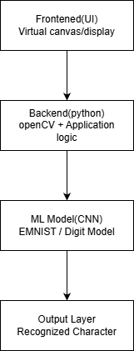

3.2 Database |Design (Entity-Relationship Diagram, Schema)
Entities
User: Stores user details who use the system.
Air_Writing : Stores air writing input details created by the user.
Character_Recognition : Stores the recognized txt result of air writing.
Device: Stores device information used for air writing.
Relationships
User → Air_Writing (1:M): One user can perform many air writing sessions.
Air_Writing → Character_Recognition (1:1): Each air writing input gives one recognition result.
Device → Air_Writing (1:M): One device can be used for multiple sessions.

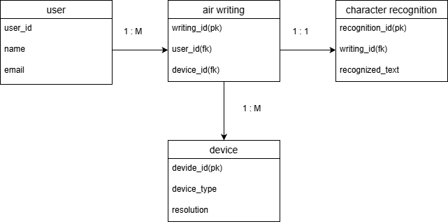

3.3 FlowChart
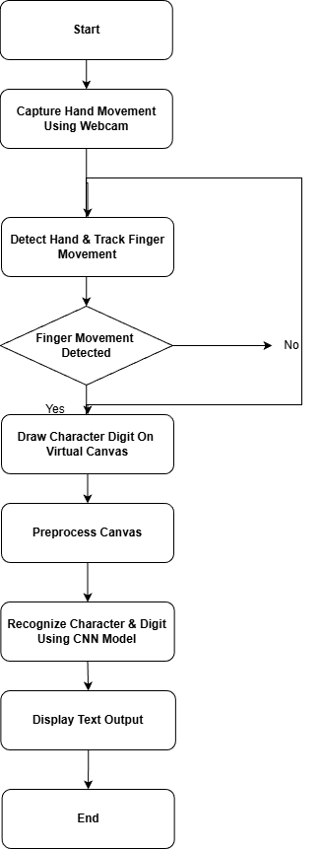

- The system starts by capturing real-time hand movement using a webcam.
- Each video frame is processed to detect the hand and track finger movement.
- The system checks whether valid finger movement for air writing is detected.
- If detected, the written character or digit is drawn on a virtual canvas.
- The drawn input is preprocessed and recognized using a trained CNN model.
- The recognized character or digit is displayed as text output, completing the process.
3.4 DFD Diagrams

Level 0 (context diagram)
Actors:
- User → The person performing gestures in the air.
- Device (Camera/Sensor) → Captures the user’s gestures as raw data.
- Air-Writing-and-Character-Recognition System (Process 0) → Core processing unit that interprets gestures and recognizes characters.
- External Database (Storage) → Stores user/system settings and processed recognition data.
Data Flow:
- User → System: Sends Gesture Input to the system.
- Device → System: Sends Raw Gesture Data captured by camera/sensor.
- System → User: Sends Recognition Output (recognized text or result).
- System ↔ External Database: Sends Processed Recognition Data for storage.
- Receives User/System Settings from the database.

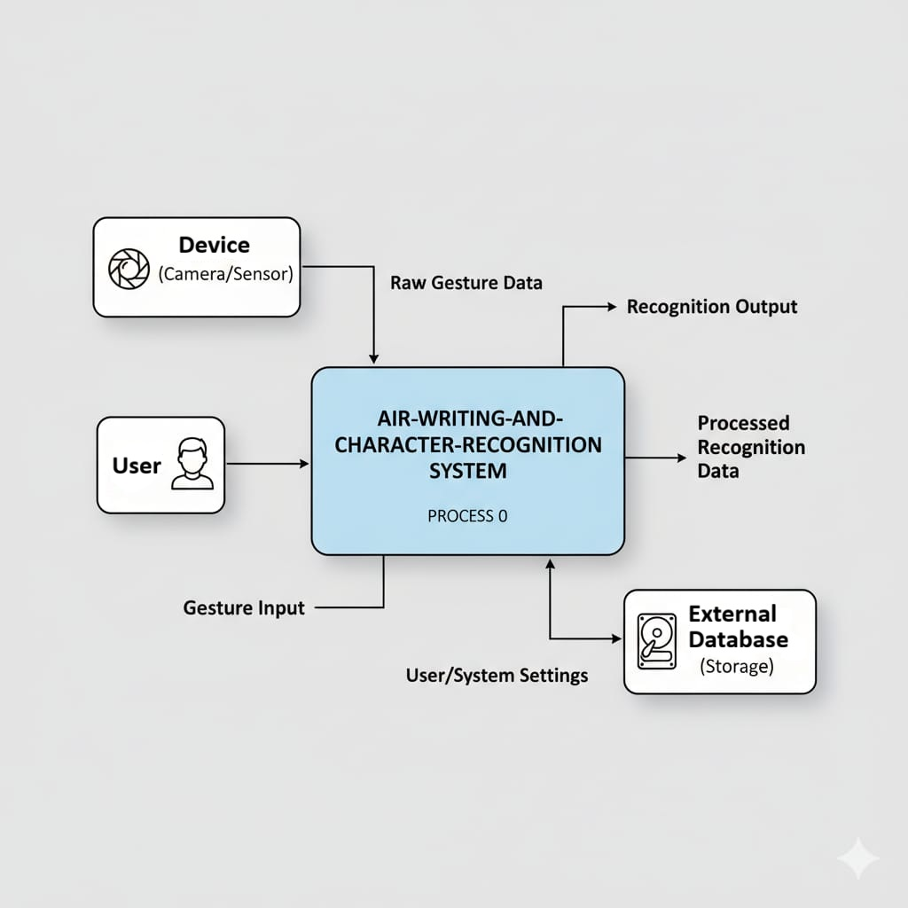

Level 1 (Detailed View)
- User performs gestures captured by a Device (camera or sensor).
- 1.0 Capture Gesture Data: The system collects raw gesture data from the device.
- 2.0 Preprocess Gesture Data: Noise is removed, and the gesture data is cleaned and prepared for recognition.
- 3.0 Recognize Gesture Data: The processed gesture is compared with stored recognition models (D2) to identify the gesture.
- 4.0 Recognize & Manage Data: Recognized results are managed, and relevant user/session data (D3) is updated.
- 5.0 Store and Maintain: Final recognition outputs and feedback are stored in the External Database for future reference.
Data Stores Used:
D1: Gesture Data Store
D2: Recognition Models
D3: User & Session Data

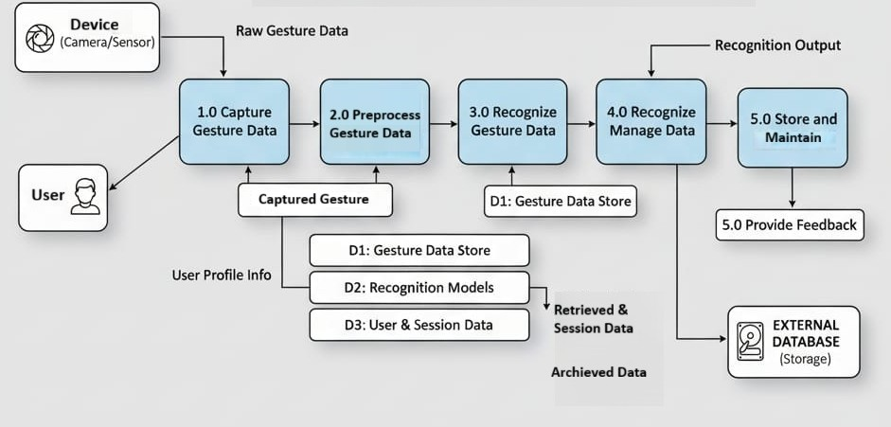

3.5 Use Case Diagrams
Actors
- user
Use Cases
- Start Air Writing
- Capture Gesture
- Recognized Character
- Recognized Text
- Store Recognition Result
- Display Text Output

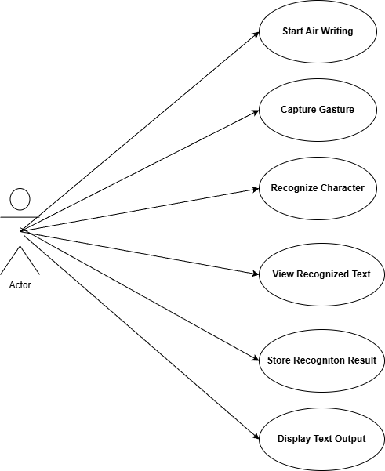

CHAPTER 4 : IMPLEMENTATION OVERVIEW

4.1 Tools and Technologies Used
The Air Writing and Character Recognition System is developed using various tools and technologies that support real-time hand tracking, image processing, and machine learning–based character recognition. The selection of these tools ensures accuracy, efficiency, and ease of implementation.
- Python : Python is used as the primary programming language due to its simplicity, extensive library support, and suitability for machine learning and computer vision applications.

- OpenCV : OpenCV is used for real-time video capture, image processing, and frame manipulation. It enables the system to efficiently process webcam input and track hand movements.

- MediaPipe : MediaPipe is utilized for hand detection and finger landmark extraction. It provides fast and accurate hand tracking, which is essential for air writing.

- Machine Learning Framework (TensorFlow / Keras) : TensorFlow and Keras are used to build and implement the CNN model for recognizing handwritten characters and digits drawn in the air.

- NumPy : NumPy is used for numerical operations and image preprocessing such as resizing, normalization, and reshaping of input data.

- SQLite / CSV / JSON : These are used to store recognized characters, logs, and experimental data generated during system execution.

- Jupyter Notebook / VS Code : These tools are used for model training, experimentation, debugging, and overall development of the project.

4.2 Algorithm And Model Description
- A webcam is used to capture real-time hand and finger movement for air writing.
- Video frames are pre-processed to remove noise and improve image quality.
- Hand and finger landmarks are detected using computer vision techniques.
- The finger movement is tracked to draw characters on a virtual canvas.
- The drawn character image is resized and normalized (28×28 format).
- A trained CNN (Convolutional Neural Network) model is used to recognize characters and digits.
- The model predicts the corresponding character or digit.
- The recognized output is displayed as text on the screen.

CHAPTER 5 TESTING AND RESULT

5.1 Testing Strategy
Definition : Testing Strategy explains how the Air-Writing and Character Recognition system was tested based on its actual implemented modules, including gesture capture, air writing, character segmentation, recognition, result display, and data handling to ensure correctness and reliability.

5.1.1 Test Plan
Definition : The Test Plan describes the overall strategy and roadmap followed to test the Air-Writing and Character Recognition project using real-time camera input and trained machine learning models.

5.1.1.1 Objective of Testing
The objective of testing is to verify that the system accurately captures air-written gestures, processes hand movements, segments characters correctly, recognizes alphabets and digits using trained ML models, and displays and stores results as expected.

5.1.1.2 Scope of Testing
- Testing was performed on the following actual implemented modules of the system:
- Video Capture Module (capture.py)
- Hand Tracking Module (HandTrackingModule.py)
- Air Writing / Virtual Drawing Module (VirtualPainter.py)
- Character Segmentation Module (character_segmenter.py)
- Character Recognition Module (character_recognition.py)
- Digit Recognition Module (digit_recognition.py)
- EMNIST Alphabet Recognition Module (emnist_recognition.py)
- Multi-Recognizer Module (multi_recognizer.py)
- Result Display Module (result_display.py, app.py)
- Data Saving & Preprocessing Module (save_preprocess.py)
- Main Controller Module (main.py)

5.1.1.3 Testing Approach
- Manual testing was performed using real-time hand gestures captured through a webcam.
- Individual modules were tested separately to verify their functionality (Unit Testing).
- Integrated testing was performed to verify data flow between modules such as capture → tracking → writing → segmentation → recognition → display.
- Final system testing was conducted to validate complete end-to-end execution.
5.1.1.4 Test Environment
Testing was carried out in the following environment:
- Programming Language : Python 3.10+
- IDE / Tools : VS Code, Jupyter Notebook
- Libraries : OpenCV, NumPy, TensorFlow, Keras, Pandas, Flask
- Model Files : .h5 trained CNN models
- Hardware : Webcam / Camera
5.1.1.5 Entry and Exit Criteria
Entry Criteria :
- Webcam is properly connected and working
- Required Python libraries are installed
- Trained model files (.h5) are available
- Source code is free from syntax errors
Exit Criteria
- All planned test cases are executed
- No critical errors are present
- System generates correct recognition output
5.1.2 Test Suite
Definition : A Test Suite is a collection of test cases designed to test a specific module or functionality of the system.
Test Suites Used in the Project
- Test Suite 1: Video Capture & Hand Tracking Test Suite
Test cases include:
Capturing live video frames
Detecting hand landmarks correctly
- Test Suite 2: Air Writing & Segmentation Test Suite
Test cases include:
Drawing air-written strokes
Segmenting strokes into individual characters
- Test Suite 3: Character & Digit Recognition Test Suite
Test cases include:
Alphabet recognition
Digit recognition
Correct label mapping
- Test Suite 4: Result Display Test Suite
Test cases include:
Displaying recognized text
Handling invalid or empty recognition results
- Test Suite 5: Data Storage & Preprocessing Test Suite
Test cases include:
Saving preprocessed gesture data
Logging recognition output
Test Suite Summary
All test suites were executed successfully. The system correctly handled valid air-written gestures and managed invalid or unclear inputs without crashing.

5.1.3 Types Of Testing Used

- Unit Testing :
Each module such as capture, hand tracking, segmentation, and recognition was tested independently.
- Integration Testing
Interaction between multiple modules was tested: Capture → Hand Tracking → Air Writing → Segmentation → Recognition → Display.
- System Testing
The complete application was tested as a single unit using real-time air writing.
Validation Testing
The recognized characters were compared with expected characters to validate accuracy.
5.1.4 Tools Used for Testing
- Python environment
- VS Code / Jupyter Notebook
- OpenCV for vision-based testing
- TensorFlow / Keras for ML model validation
- Manual verification of outputs
5.1.5 Test Data
- Real-time air-written hand gestures
- EMNIST dataset for alphabet recognition
- Digit dataset for digit recognition
- Both valid and invalid gesture inputs

5.2 Test Cases
Definition : A test case specifies the input condition ,expected output and actual result to verify correct functioning of the system.
5.2.1 Test Case Table
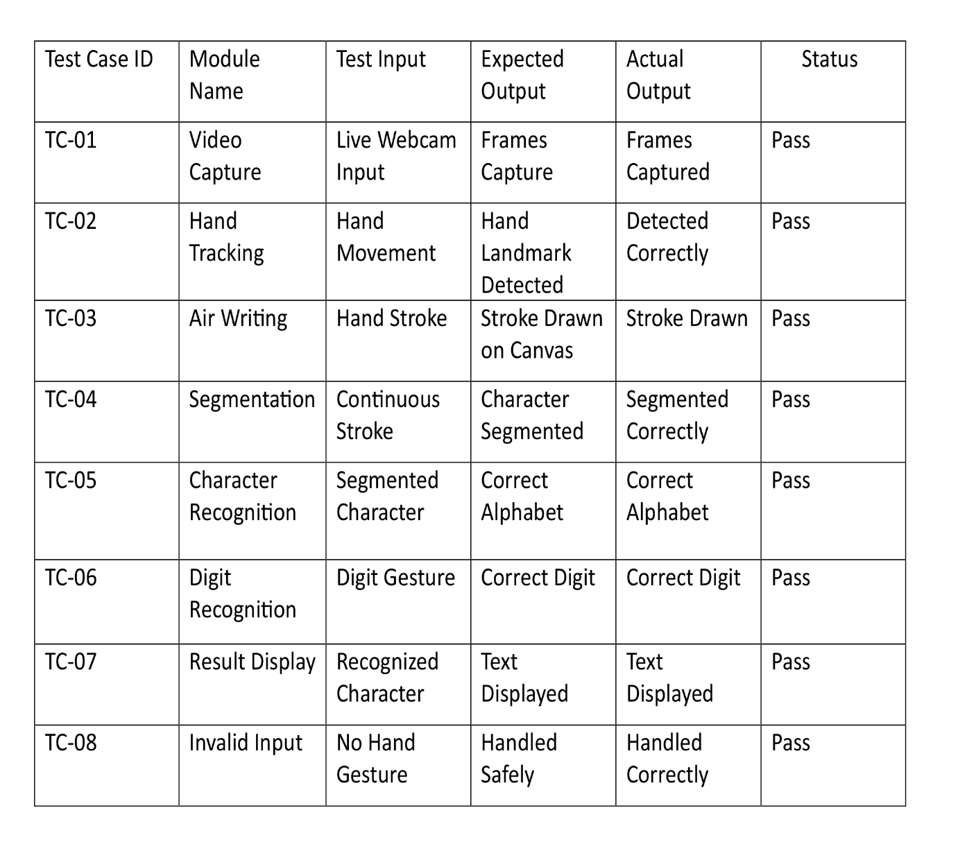

5.2.2 Number of Test Cases
Total number of test cases : 8
Test cases passed : 8
Test case Failed : 0
Test case cover : Normal input ,edge cases ,invalid input and complete system execution.

5.2.3 Test Case Execution Summary
The air writing and character recognition system passed all test cases successfully and performs as expected.
5.3 Result Analysis

The Air Writing and Character Recognition system was tested under different conditions using real-time hand movement input. The hand detection and finger tracking module accurately captured air-written characters in most cases.The trained CNN model successfully recognized characters and digits with good accuracy and real-time performance. The recognized text was displayed correctly on the screen.Minor performance variations were observed under poor lighting conditions. Overall, the system performed efficiently and met the objectives of the project.

5.4 Output Screenshot

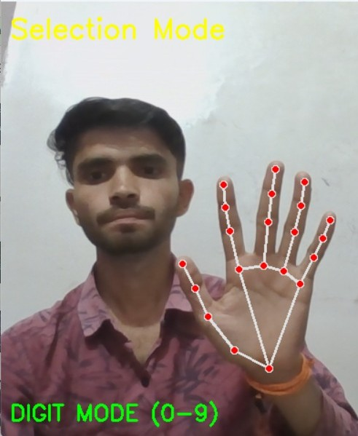
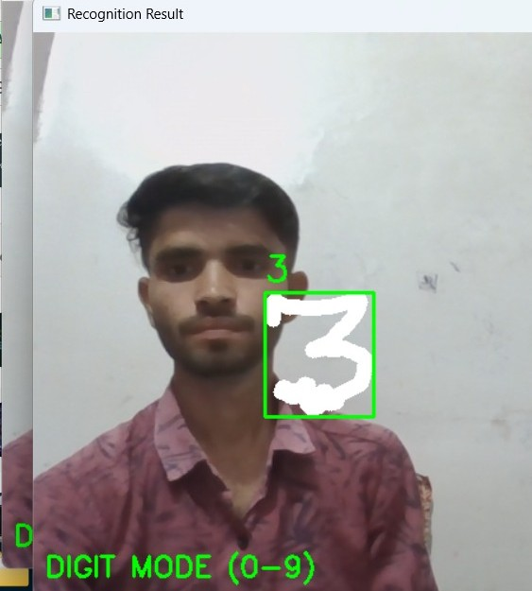

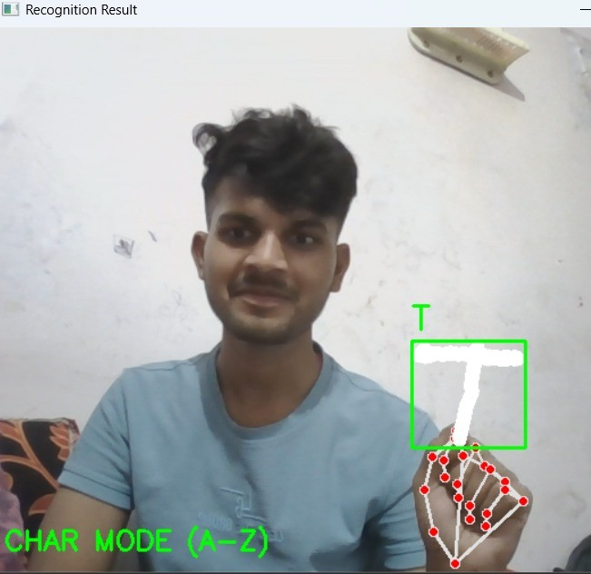
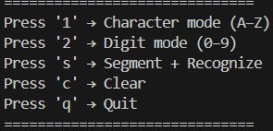

CHAPTER 6 : CONSLUSION AND FUTURE SCOPE

6.1 Conclusion
The Air Writing and Character Recognition System successfully demonstrates the use of computer vision and machine learning techniques to recognize characters and digits written in the air using hand movements. The system captures real-time video input through a webcam, tracks finger movements, processes air-written strokes, and accurately recognizes characters using trained CNN models.The recognized output is displayed as readable text, ensuring smooth and real-time performance under normal lighting conditions. Testing results confirm that the system works reliably and meets the project objectives. Overall, the project provides an effective and innovative solution for contactless writing and human–computer interaction.

6.2 Future Scope
- The system can be extended to recognize continuous air writing, enabling full word and sentence formation.
- Integration of advanced deep learning models (LSTM / Transformer-based networks) can improve accuracy and speed.
- Support for multiple languages and handwriting styles can be added.
- Integration with AR/VR and smart devices can enable touchless interaction systems.
- The system can be used in education, healthcare, and assistive technology applications.
- Performance can be enhanced for low-light and complex background conditions.

REFERENCES

Kaggle, Hand Gesture and Character Recognition Datasets, Available at:
https://www.kaggle.com
Google MediaPipe Documentation, Hand Tracking and Landmark Detection, Available at:
https://developers.google.com/mediapipe
OpenCV Documentation, Computer Vision Library, Available at:https://opencv.org
Scikit-learn Documentation, Machine Learning in Python, Available at:
https://scikit-learn.org
TensorFlow Documentation, Deep Learning Framework, Available at:
https://www.tensorflow.org
APPENDICES

Appendix A :
- Github Repository:
https://github.com/Vikashrajpoot2610/Air-writing-Computer-Vision
- Source Code : Snapshot

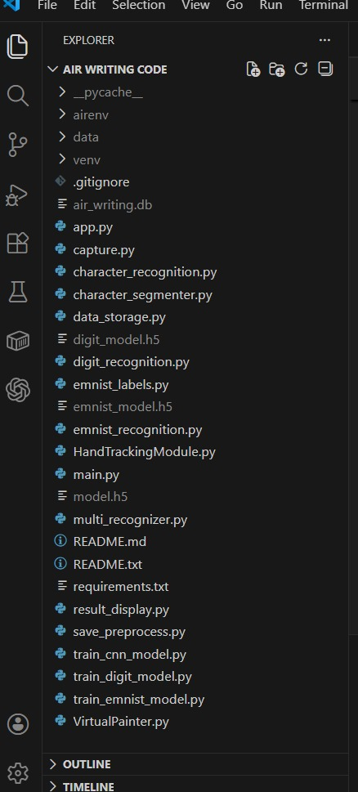

Appendix B : Project Timeline

Phase Activity Description Duration

Phase 1 Requirement analysis & 1 week
problem study
Phase 2 Dataset collections & 1 week
Preprocessing data
Phase 3 Model design & 1 week
Training
Phase 4 System implementation & 1 week
Integration
Phase 5 Testing & validation 1 week

Phase 6 Documentation &final 1 week
Submission

Appendix C : Team Member Contribution

Member 1 (Naman Mishra) : Handled requirement analysis, problem study, SRS preparation, and dataset collection. Also contributed to preprocessing of gesture and character datasets.
Member 2 (Vikash Rajpoot) : Developed the air writing module, hand tracking using MediaPipe/OpenCV, character segmentation logic, and assisted in system integration.
Member 3 (Dipanshu Sahu) : Implemented character and digit recognition models using CNN, performed system testing and validation, and prepared final documentation and report.

Appendix D : DATASET DETAILOS AND SOURCES

The dataset used in the Air Writing and Character Recognition project is obtained from publicly available Datasets (Kaggle) and real-time webcam inputs. The dataset consists of hand gesture images and air-written character samples, which are processed into numerical features for training and testing the recognition models. Proper preprocessing, normalization, and dataset splitting are applied to ensure accurate model performance.

Table 2.1 Dataset Description Table :

